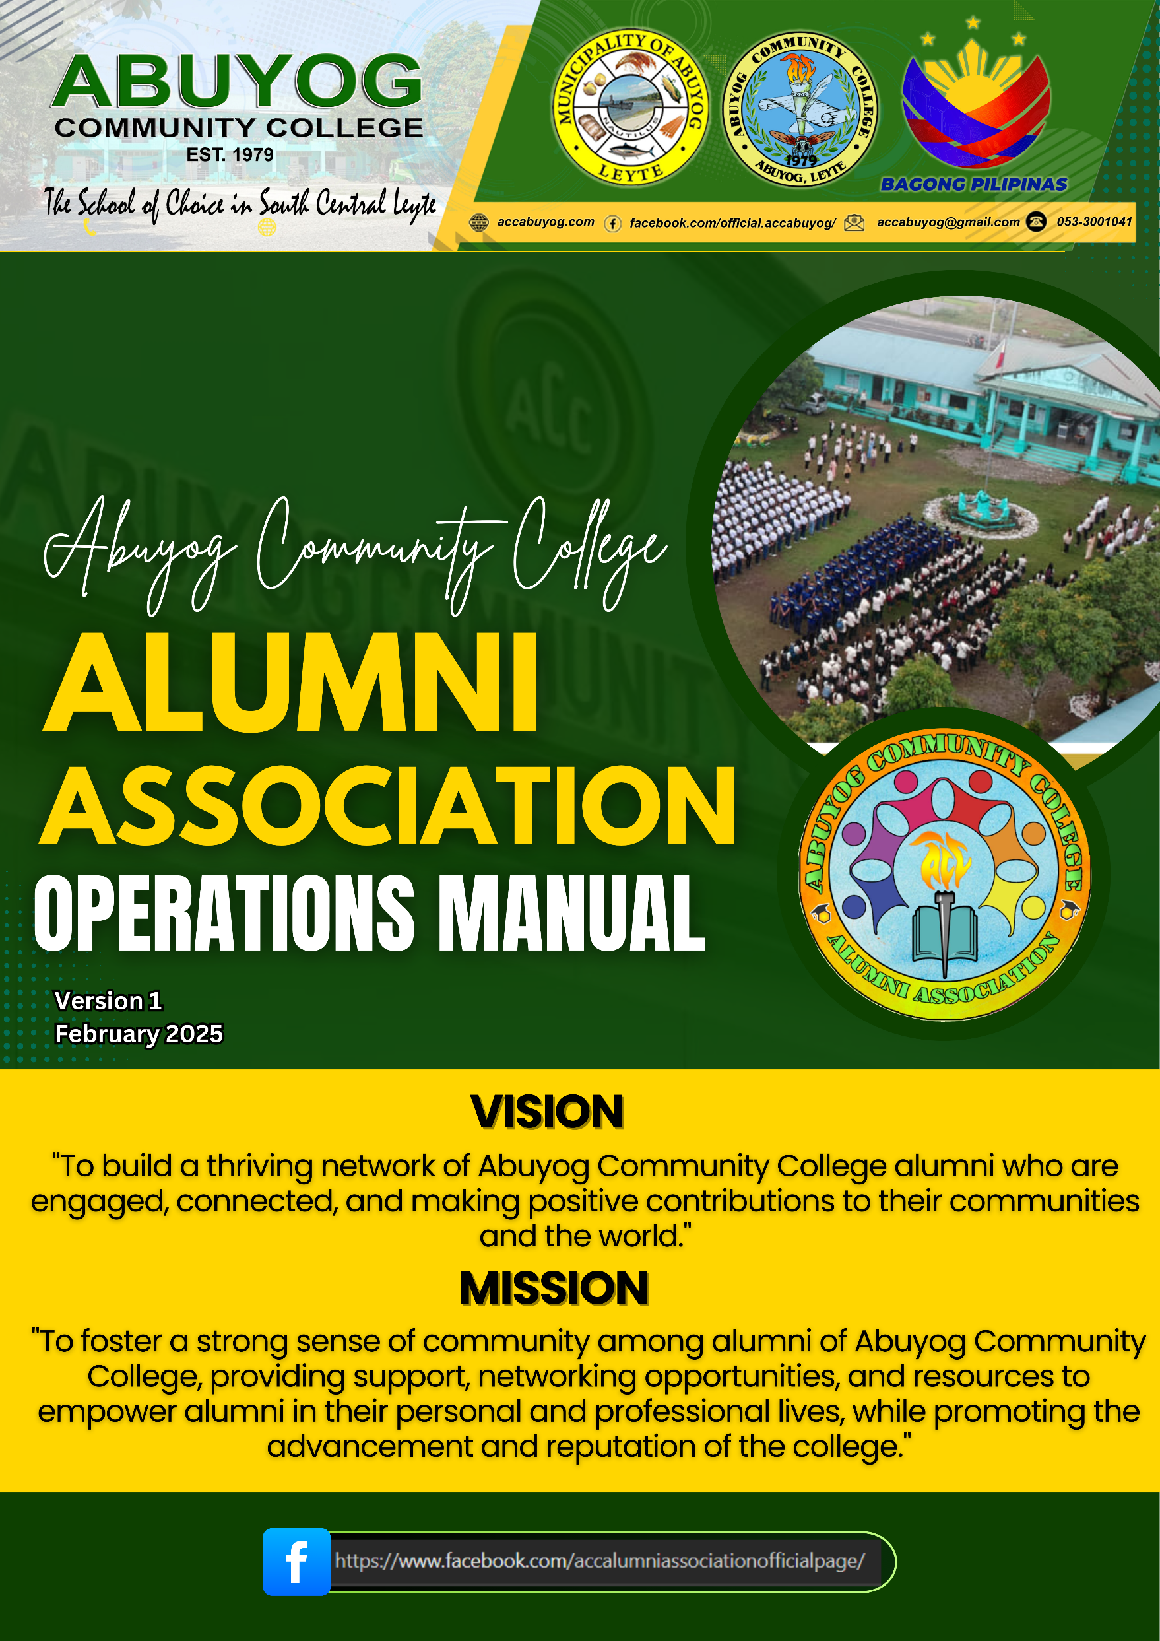

**TABLE OF CONTENTS**

**I. RATIONALE**

**II. OVERVIEW OF ABUYOG COMMUNITY COLLEGE ALUMNI ASOCIATION (ACC-AA)**

1. VISION, MISSION AND GOALS
2. LOGO
3. ORGANIZATIONAL STRUCTURE
4. OFFICERS
5. DUTIES AND RESPONSIBILITIES – OFFICERS
6. DUTIES AND RESPONSIBILITIES – COMMISSIONS
7. COMMITTEES

**III. PROTOCOLS, PROCESS GUIDES AND PROCEDURES**

1. MEETINGS
2. COMMUNICATIONS PROTOCOLS
3. PROCEDURE FOR PROCESSING ALUMNI MEMBERSHIP
4. PROCEDURE FOR PROCESSING ORANIZATION MEMBERSHIP APPLICATIONS
5. CHAPTERING GUIDE
6. SCHOLARSHIP GUIDE
7. DISPUTE RESOLUTION GUIDE
8. FINANCIAL POLICIES AND PROCEDURES
9. ELECTION PROCEDURE FOR ALUMNI OFFICERS
10. GUIDELINES FOR THE DISTINGUISHED ALUMNI AWARDS
11. LEGAL AID BUREAU PROGRAM

**IV. FEES AND DUES**

A. ASSOCIATION DUES

B. SUPPORT FUND

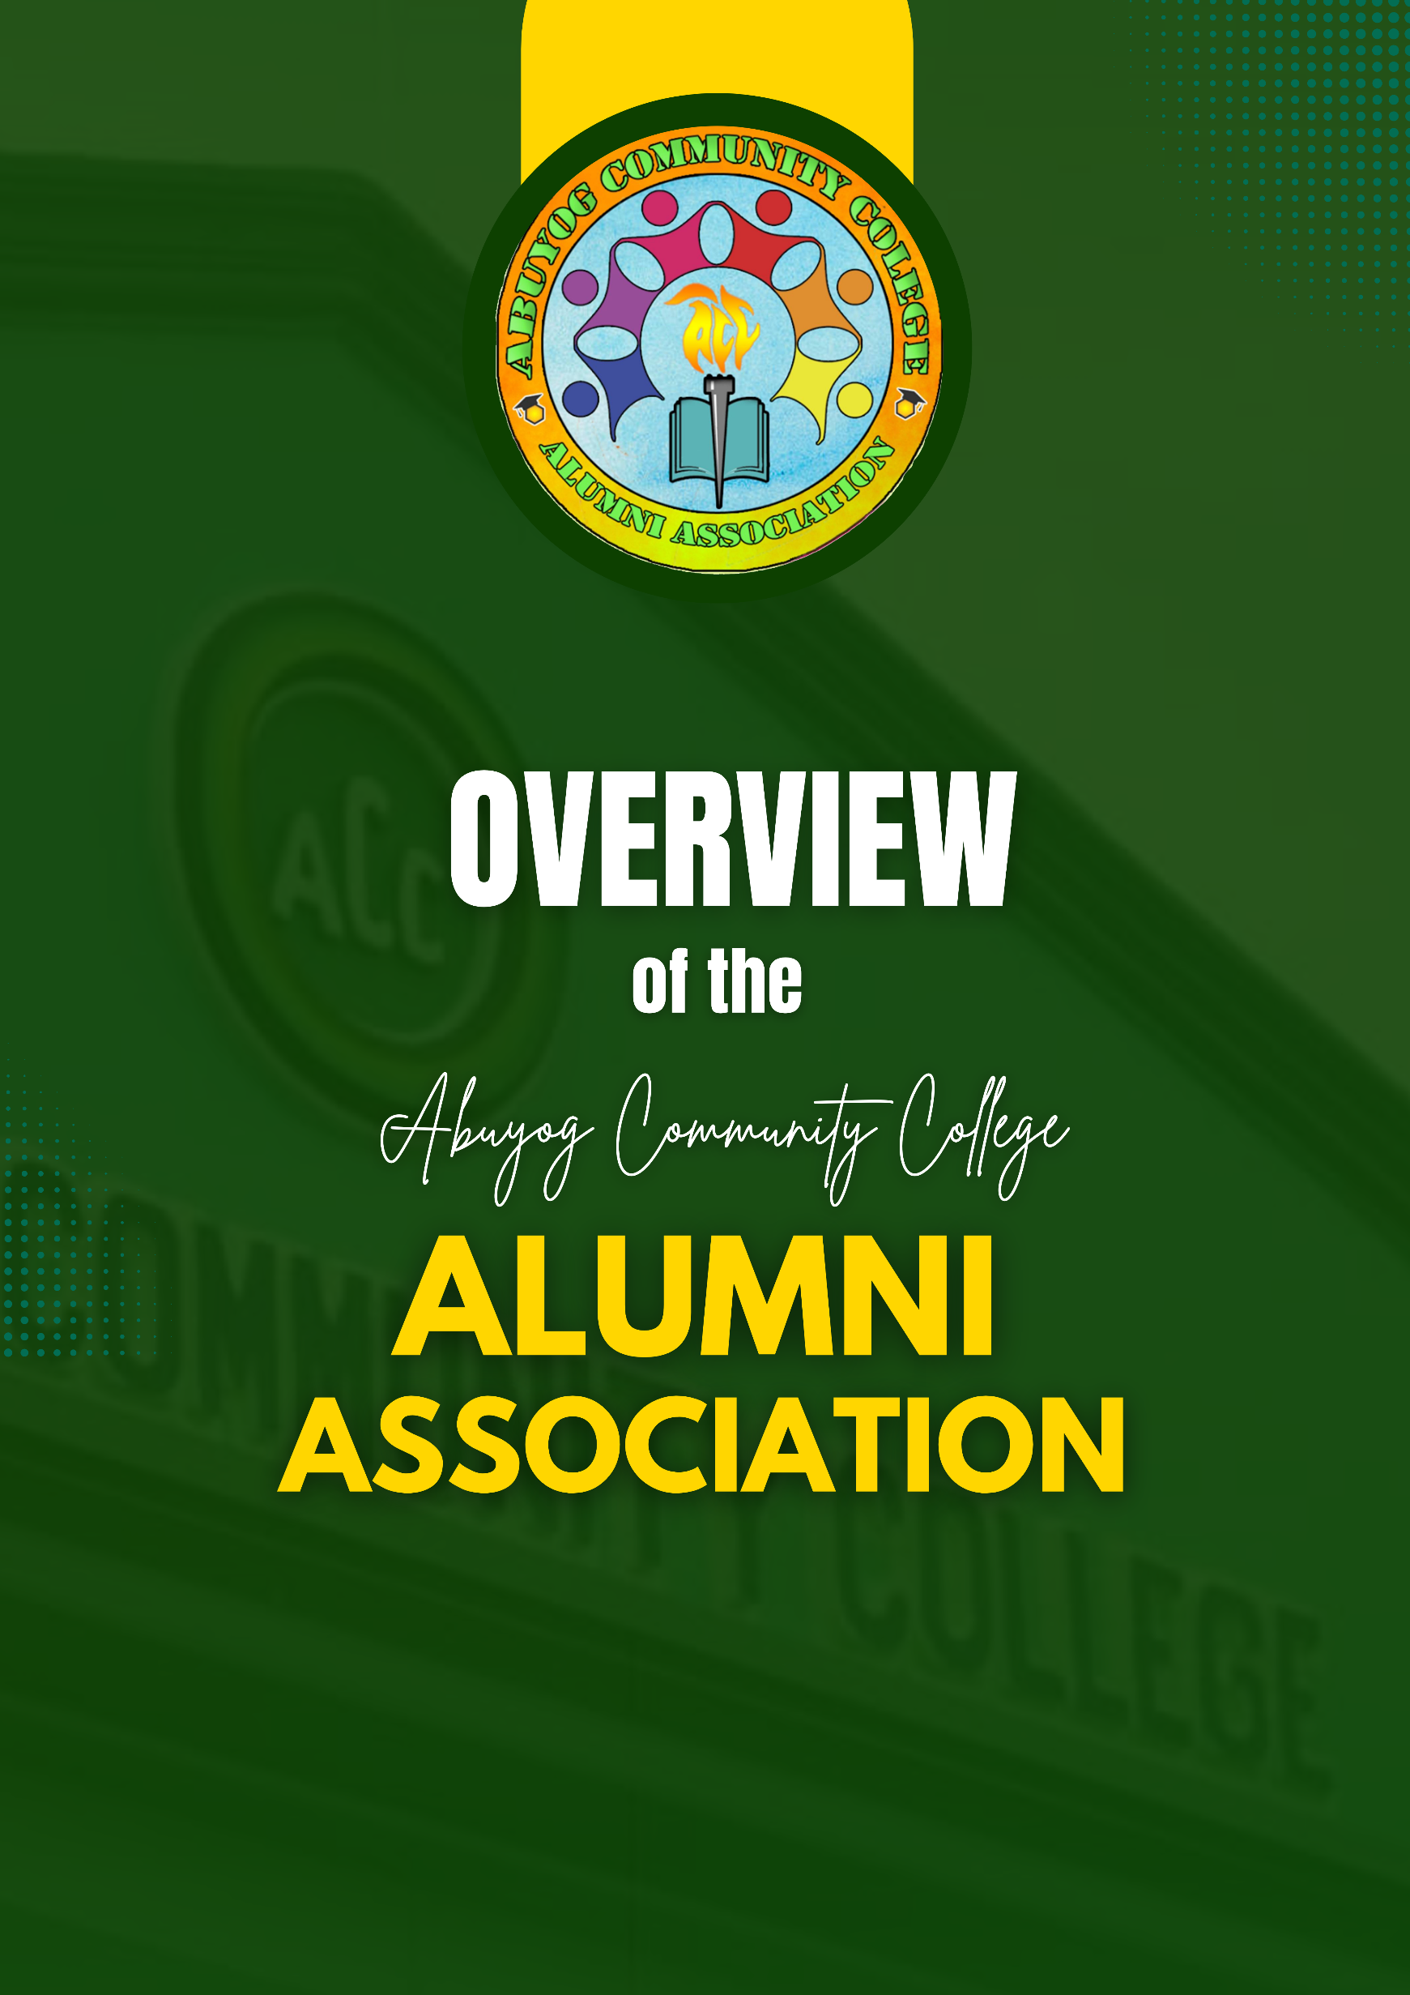

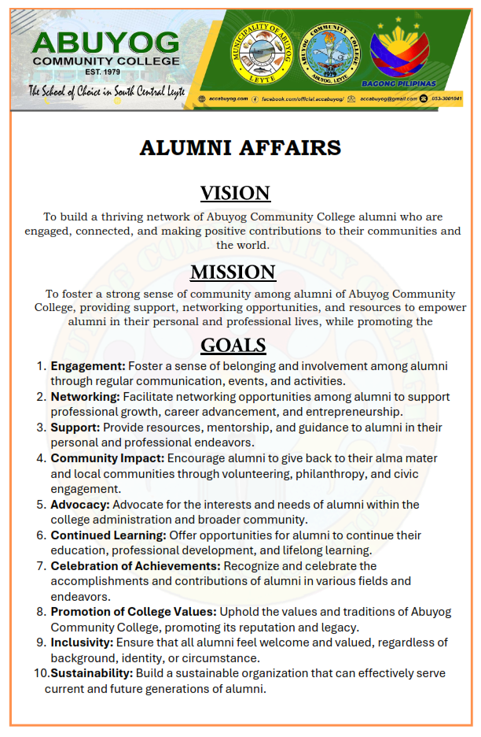

**ACC Alumni Association Logo**



The logo for **ACC Alumni Association**, featuring a torch at its center, a book placed beneath the torch, alumni encircling the torch and a honeycomb with a graduation hat embodies a profound representation of the Alumni Association’s mission and values.

1. **Torch:** symbolizes the association's commitment to knowledge and leadership, indicating its dedication to lifelong learning and the cultivation of leadership qualities among its members. It also represents empowerment, unity, and the preservation of the college's values and traditions, emphasizing the importance of guiding and inspiring future generations of alumni.
2. **Alumni holding hands:** exemplifies the strong sense of community and support within the association. It signifies unity, collaboration, and mutual assistance among members, illustrating their shared commitment to personal and professional growth, as well as their willingness to uplift and empower each other.
3. **Book beneath the Torch:** underscores the association's emphasis on education, intellectual growth, and excellence. It symbolizes the importance of continuous learning and the pursuit of knowledge, as well as the transmission of wisdom and tradition from one generation of alumni to the next.
4. **Honeycomb with Graduation Cap:** further reinforces the sense of community and collaboration among association members. It represents collective effort, intellectual achievement, and adaptability, highlighting the diverse talents and contributions of alumni as they work together to address challenges and drive innovation in their respective fields.
5. **Gold Color:** represents pride and optimism among members of the association. It reflects the sense of pride that alumni feel in their alma mater and their accomplishments, as well as their optimistic outlook towards the future. This optimism is rooted in the belief that through collaboration and perseverance, alumni can continue to make significant contributions to their communities and society as a whole.
6. **Blue Color:** symbolizes trust and unity among members. Blue is often associated with stability and reliability, reflecting the trust that alumni have in each other and in the values upheld by the association. It underscores the importance of building strong relationships based on mutual respect and support within the alumni community.

Together, these elements embody the ACC Alumni Association's dedication to fostering a supportive community of lifelong learners who uphold the values of knowledge, unity, excellence, and innovation. They serve as a powerful symbol of the association's mission to empower alumni to make a positive impact in their professions, communities, and society at large.

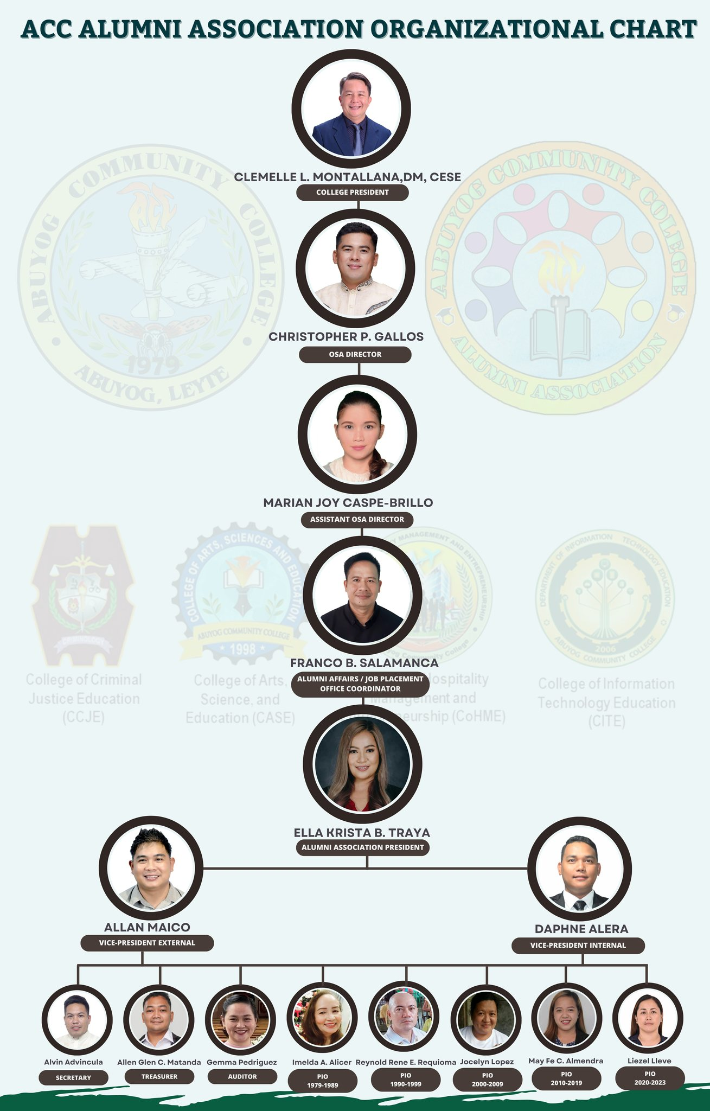

**D. OFFICERS:**

**President:** Ella Krista Traya

**VP External:** Allan Maico

**VP Internal:** Daphne Alera

**Secretary:** Alvin Advincula

**Treasurer:** Allen Glen Matanda

**Auditor:** Gemma Pedriguez

**PIO:**

**1979-1989:** Nilda Alonzo

**1990- 1999:** Rene Reynold Requioma

**2000-2009:** Jocelyn Lopez

**2010- 2019:** May Fe Almendra

**2020-2023:** Liezel Lleve

**E. DUTIES AND RESPONSIBILITIES – OFFICERS**

The governing body of **ACC-AA** consists of elected representatives responsible for making strategic decisions for the organization.

* **President:**
  1. Takes the role of chief executive officer and official spokesperson of the

Association.

* 1. Presides in meetings of the Board of Trustees, and if delegated to do so by the Chairman, in meetings of the members of the Association.
  2. Executes all resolutions of the Board of Trustees.
  3. Directs and oversees the activities of the Association.
  4. Submits to the Board, as soon as possible after the close of each Fiscal Year, and to the member-AAs at the annual meetings, a complete report of the activities and operations of the Association for the Fiscal Year under his term.
* **Vice President (External):** 
  1. Manages external affairs and partnerships.
  2. Exercises the powers and performs all duties of the President during the absence or incapacity of the latter.
  3. Over-sees the functioning of the Committees of the Association.
  4. Performs such duties as may be assigned to him/her by the President.
* **Vice President (Internal):** 
  1. Oversees internal operations and membership engagement.
  2. Exercises the powers and performs all duties of the President during the absence or incapacity of the latter.
  3. Over-sees the functioning of the Committees of the Association.
  4. Performs such duties as may be assigned to him/her by the President.
* **Secretary:** 
  1. Sends all notices required in the By-Laws.
  2. Takes the Minutes of all meetings of the members and the Board of Trustees and keeps copies thereof in a book kept for the purpose.
  3. Keeps the seal of the Association and affixes such seal to any paper or instrument requiring the same.
  4. Keeps and maintains the member’s register, the correspondence files and all records of the Association.
  5. Undertakes the on-boarding process for new Trustees.
  6. Oversees the workings of the Association to ensure good corporate governance.
* **Treasurer:**
  1. Takes charge of the funds, receipts, and disbursements of the Association.
  2. Keeps all moneys and other valuables of the Association in such banks as the
  3. Board of Trustees may designate.
  4. Keeps and takes charge of the books of accounts, an account of the financial condition of the Association, and of all transactions s/he has made as Treasurer.
  5. Reports on the Association’s income and expenditures to the Board and at the members’ annual meeting.
* **Auditor:**

1. Oversees day-to-day accounting functions, integrating finance operations, forecasting and budgeting, handling tax matters, preparing financial reports, and ensuring organizational financial stability.

* **Public Information Officers (PIO):** 
  1. Prepares statements, news stories/articles for press releases on all the activities and projects of the Association.
  2. Takes charge of giving the press kits to all media outlets for information/publicity purposes.
  3. Arranges any and/or all press conferences for media coverage of any and/or all major significant events and activities of the Association.
  4. Coordinates with all media outlets on matters relating to the Association and its activities.

**F. DUTIES AND RESPONSIBILITIES-COMMISSIONS**

1. **Dispute Resolution Commission (DRC)**  
   The DRC is empowered to hear and resolve issues that arise:
   1. Between the Association and its Member Organizations: Handling disputes between ACC-AA and its member bodies.
   2. Among Member Organizations: Addressing conflicts that occur between and among the association’s member groups.
   3. Intra-Organizational Disputes: Resolving internal corporate disputes within member organizations (excluding personal issues).  
      **Procedures:**
      * Submission: A formal complaint is submitted with detailed documentation.
      * Mediation: Informal mediation is first attempted through the Alumni Affairs Committee.
      * Hearing: If unresolved, a formal hearing is conducted by the DRC.
      * Decision: The DRC renders a final, binding decision.
2. **Commission on Elections (COMELEC)**  
   The COMELEC is tasked with administering all election-related processes within ACC-AA to ensure:
3. Fairness: The electoral process is free, fair, and transparent.
4. Orderliness: Elections are conducted in an orderly and peaceful manner.
5. Credibility: The process garners trust from all alumni by adhering to established guidelines.  
   **Functions:**
   * Oversee nomination, campaign, and voting procedures.
   * Verify the eligibility of candidates and members.
   * Resolve any disputes or irregularities during the election process.

**G. COMMITTEES**

**1. Academics Committee**

**Goal:** Engage actively in academic pursuits and create avenues for lifelong learning among alumni, faculty, students, and related groups.

**Functions:**

* + Participate in curricular reviews to ensure preparedness for emerging educational trends (e.g., Education 4.0).
  + Support research and innovative studies at the college.
  + Provide formal and informal educational opportunities through seminars, workshops, and mentorship programs.

**2. Advocacy Committee**

**Goal:** Realize the vision and mission of ACC-AA by championing the college’s core values.

**Functions:**

* + Promote quality education and support initiatives that foster academic excellence.
  + Assist in relief and rehabilitation efforts during community disasters.
  + Engage in outreach activities that serve societal needs, embodying the spirit of Christian charity.
  + Contribute to the achievement of sustainable development goals through targeted programs.

1. **Events Committee**

**Goal:** Create and manage meaningful activities that reinforce the college identity, values, and community spirit.

**Functions:**

* + Organize alumni events, reunions, and networking sessions to strengthen alumni solidarity.
  + Provide platforms for alumni to showcase their talents and achievements.
  + Develop annual calendars and special event proposals that reflect the association’s mission.

1. **Finance Committee**

**Goal:** Ensure sound financial management and proper stewardship of the association’s funds.

**Functions:**

* + Develop and oversee financial plans, budgets, and fundraising strategies.
  + Ensure transparency in financial reporting and monitor adherence to established financial policies.
  + Safeguard assets and provide up-to-date policies and procedural guidelines for fund management.

1. **Public Presence Committee**

**Goal:** Enhance the association’s visibility and strengthen connections with alumni and the general public.

**Functions:**

* + Disseminate accurate and timely information about ACC-AA activities and events.
  + Maximize engagement on social media platforms and other digital channels.
  + Coordinate public relations efforts to boost the association’s image and outreach.

1. **Resource Committee**

**Goal:** Identify and secure financial resources vital for the association’s operations and activities.

**Functions:**

* + Engage alumni in identifying potential patrons and sponsors.
  + Monitor and strategize fundraising efforts, including the establishment of a donor database.
  + Develop and implement initiatives to increase financial support for the association.

1. **Secretariat Committee**

**Goal:** Provide administrative and organizational support to ensure the smooth operation of ACC-AA.

**Functions:**

* 1. Prepare official announcements and correspondence for internal and external communication.
  2. Manage event registration, documentation, and record-keeping.
  3. Oversee the preparation and publication of newsletters and annual reports.
  4. Offer editing and administrative support for various association documents and publications.



**A. MEETINGS**

1. **Members’ Meetings**
   1. **Annual Meeting:** The annual meeting of the members of ACC-AA shall be held at the association’s principal office on the second Saturday of March each year.
   2. **Special Meetings:** Special meetings may be called as needed by the President, by at least one third (1/3) of the Board of Trustees, or upon petition by at least one third (1/3) of the general membership.
   3. **Elections:** The election of the President, Treasurer, and Secretary shall take place during the annual meeting every three (3) years.
   4. **Delegated Voting:** Member organizations in good standing (having met all criteria at least 30 days before the meeting) may send a delegation composed of five (5) Officers/Trustees who will attend as a group and cast one (1) vote on behalf of the member organization.
2. **Meetings of the Board of Trustees**
   1. **Composition:** The Board shall be composed of either the President or the duly authorized representative of each Regular Member in good standing.
   2. **Frequency:** Regular Board meetings shall be held at least once every quarter at dates and times determined by the President.
   3. **Special Meetings:** Special meetings may be convened by the President or upon the request of at least one third (1/3) of the Board members.
3. **Criteria for Members in Good Standing**  
   A member organization is considered in good standing if it has:
   1. Fully paid the Association Dues by January 30 of each year.
   2. Had its President or authorized representative attend at least 75% of the Board meetings in the preceding year.
   3. Participated in at least two (2) ACC-AA activities during the immediately preceding year.

**B. COMMUNICATIONS PROTOCOLS**

1. **Review and Approval:** All written communications to external parties must be reviewed and approved by the President before release.
2. **Electronic Signatures:** When warranted, Officers’ electronic signatures may be appended to documents only if the Business Manager is authorized to do so and prior approval has been secured.
3. **Official Letterhead:** The official ACC-AA letterhead is to be used exclusively for formal and official communications of the association.

**C. PROCEDURE FOR PROCESSING ALUMNI MEMBERSHIP**

**A. Payment Submission:**

* 1. Each prospective alumnus is required to pay a one-time membership fee of PHP 200.
  2. Payments can be made via cash, bank deposit, or online transfer. Detailed payment instructions, including account numbers and reference codes, are provided on the official ACC-AA website and membership application form.

**B. Receipt and Verification:**

* 1. Upon receiving the payment, the Business Manager (or designated officer) verifies the transaction using the accompanying payment slip or digital confirmation.
  2. A receipt is immediately issued to the alumnus as proof of payment, and a copy is archived in the membership records.

**C. Updating Membership Records:**

* 1. The Alumni Affairs Office updates the central membership database, marking the alumnus as an active member upon confirmation of payment.
  2. An official membership card or digital confirmation is then issued, along with relevant membership details.

1. **Notification:**
   1. The successful processing of the payment is communicated to the alumnus via email or SMS.
   2. The receipt and membership status are also logged in the association's financial and administrative systems.
2. **Follow-Up and Audit:**
   1. Any discrepancies or issues in the payment process must be reported immediately to the Business Manager or Treasurer for resolution.
   2. Regular audits of membership payments are conducted to ensure the accuracy and integrity of the financial records.

**D. PROCEDURE FOR PROCESSING ORANIZATION MEMBERSHIP APPLICATIONS**

1. **Submission:** An applicant organization must send a Letter of Intent (LOI) to ACC-AA, addressed to the President, accompanied by two copies each of the following documents:
   1. **For Incorporated Organizations:** Articles of Incorporation, By-Laws, SEC Registration Certificate, and the latest filed General Information Sheet (GIS).
   2. **For Non-incorporated Organizations:** Constitution and By-Laws or any equivalent documentation that demonstrates organizational structure.
   3. A list of incumbent Board of Directors/Trustees and Officers.
   4. A members’ list with at least fifty (50) active members, indicating those registered on the Alumni Portal of Abuyog Community College.
   5. A detailed plan of activities (e.g., alumni homecoming events, community service projects).
   6. Proof of public presence (e.g., an active website, Facebook page, or YouTube channel with at least 100 likes/subscribers).

***Note:*** *ACC-AA reserves the right to invite qualified organizations that have not submitted an application, subject to the same requirements.*

1. **Incomplete Submission:**

If the LOI lacks the required documents, ACC-AA will acknowledge receipt and provide a list of missing items to complete the application.

1. **Evaluation Process:**
   1. **Management Committee Review:** ACC-AA’s Management Committee (ManCom) will evaluate the application through interviews with key officers and a site visit (the applicant organization will host a welcome event at its principal office).
   2. **Board Review:** If the ManCom’s findings are favorable, the President will present the applicant organization to the Board of Trustees for concurrence.

**Outcome:**

* + - If the Board concurs, the organization will pay the Association Dues and receive a Certificate of Membership as a regular member of ACC-AA.
    - The new member organization will then be endorsed to the college’s Office of Alumni Relations for formal recognition.
    - Finally, the Officers and Board of the new member organization will take their oath and receive an official welcome, and a representative will join the Board of Trustees.

**E. CHAPTERING GUIDE**

ACC-AA serves as the mother organization for all recognized alumni associations of Abuyog Community College. In its mission to foster a dynamic and expansive alumni community, ACC-AA aims to activate new chapters both domestically and abroad.

**Steps to Convene a Chapter:**

1. **Data Collection:** Gather data on alumni residing and working in a specific area.
2. **Needs Analysis:** Survey and analyze the local needs to assess chapter viability.
3. **Letter of Intent:** Submit a LOI to ACC-AA.
4. **Social Media Engagement:** Create a dedicated Facebook group for interested alumni.
5. **Organizational Meeting:** Hold a meeting to prepare necessary chapter documents.
6. **Accreditation:** Receive an acceptance letter and accreditation from ACC-AA.
7. **Launch:** Officially launch the chapter and induct its officers.

**F. SCHOLARSHIP GUIDE**

**Policy Statement:**  
 ACC-AA, in collaboration with the Abuyog Community College Alumni Foundation, is dedicated to providing financial assistance to disadvantaged students who are at risk of not completing their studies due to financial hardship. This commitment is executed through a specialized scholarship program aligned with the college’s standards.

**Program Description:**

1. The scholarship targets qualified third-year and graduating students.
2. It operates on a study-now-pay-later basis, ensuring the sustainability of the program.
3. Beneficiaries are expected to repay the financial assistance (without interest) three (3) years after graduation, which is regarded as a moral obligation.

**Benefits:**

1. The successful applicant will receive a **50% subsidy** on the total fees due to Abuyog Community College.
2. Subject to the availability of funds, the beneficiary may also receive additional financial assistance for thesis writing.

**Requirements:**

1. Must be a bona fide student of Abuyog Community College in the third or senior year of his/her course.
2. Must not have any derogatory record in Abuyog Community College or elsewhere.
3. Must have achieved an average of at least **85%** in the immediately preceding semester.
4. Must be a member of a college-recognized student organization.
5. Must be endorsed by a member Alumni Association in good standing with ACC-AA.

**Procedures to Qualify for the Scholarship:**

1. **Submission:**
   * The interested student must submit a letter of request for assistance, addressed to the ACC-AA Advocacy Committee. This letter should include an explanation of the circumstances necessitating financial assistance.
   * The request must be co-signed by one of the student's parents.
   * The following documents must accompany the request:
     + A promissory note agreeing to repay the funds three years after graduation.
     + An expression of willingness to volunteer in the Student Work Immersion Program (SWIP) of ACC-AA.
2. **Initial Review:**
   * The ACC-AA Advocacy Committee will conduct an initial review of the letter-request. If found satisfactory, the student will be advised to submit additional documents, including:
     + A certification of good moral character from the Dean’s Office (noted by the Head of the Office for Student Affairs).
     + A copy of the Barangay clearance.
     + A current utility bill (e.g., Meralco billing) as proof of residency.
3. **Evaluation and Interview:**
   * The Advocacy Committee will evaluate the complete application. If the application meets the required standards, the student will be scheduled for an interview.
4. **Endorsement and Approval:**
   * If the applicant is found deserving, the Committee will forward a favorable endorsement to the Presidents of ACC-AA and the Scholarship Fund Committee.
   * If not found deserving, the student will be notified along with the reasons for the decision.
5. **Execution of Agreement:**
   * The Presidents of ACC-AA and the Scholarship Fund Committee, the Advocacy Committee, and the scholar (together with one or both parents) will meet to execute a Memorandum of Agreement (MOA).
   * Following the MOA, the Treasurer of the Scholarship Fund will be authorized to release the funds.
6. **Documentation:**
   * The successful applicant must secure and complete a Scholarship Form from the Office of Student Affairs (OSA) at the designated campus office and submit a copy to the ACC-AA office.

**Procedures for Renewal of the Scholarship:**  
 The scholarship will continue for the term specified in the MOA, provided that the following conditions are met:

1. The scholar must maintain an average of at least **85%** in each subsequent semester.
2. The scholar must submit a copy of his/her grades each semester.
3. The scholar must not drop or fail any course during the scholarship period.
4. The scholar must comply with all school rules.
5. The scholar must complete a Scholarship Renewal Form and submit it to the Office of Student Affairs.
6. A copy of the completed Renewal Form must also be submitted to the ACC-AA office.

**G. DISPUTE RESOLUTION GUIDE**

ACC-AA encourages its members to settle disputes internally through counseling and mediation. If these informal measures fail, the dispute resolution process outlined below shall be followed:

**Procedure:**

1. **Submission of Complaint:**
   * The complainant shall submit a written request to the Dispute Resolution Commission (DRC) of ACC-AA. The letter must specify the names and addresses of the parties involved, along with a brief statement of the issues. All supporting evidence must be attached.
2. **Response by the Respondent:**
   * The DRC will forward a copy of the complaint, along with all attachments, to the respondent(s) and require them to provide their comments and any counter-evidence.
3. **Reply:**
   * Upon receiving the respondent's comments, the DRC will send a copy to the complainant and request a reply that addresses the respondent’s submissions.
4. **Hearing and Deliberation:**
   * The DRC will convene a meeting with the involved parties to discuss and deliberate on the issues. A conference may be arranged if deemed necessary to reach an equitable resolution.
5. **Decision:**
   * The DRC will render its decision in writing, ensuring that all parties receive a copy of the decision.
6. **Finality:**
   * The decision rendered by the DRC is final and binding on all parties.

**H. FINANCIAL POLICIES AND PROCEDURES**

**1. Check Voucher and Check Preparation**

1. **Initiation:**
   * The Business Manager informs the President and the Treasurer that a check needs to be issued, including all pertinent details. This notification can be made informally via digital messaging (e.g., Facebook Messenger) or preferably through a formal Check Requisition Form.
2. **Approval:**
   * The President and the Treasurer review and approve the requisition, either through informal digital communication or by signing the Check Requisition Form—physically or electronically.
3. **Processing:**
   * After approval, the Business Manager will:
     + Fill in the electronic Check Voucher form.
     + Prepare the check in the pre-approved amount.
     + Route the voucher and the check to the President and the Treasurer (or their designated alternates, if necessary) for physical signatures.
     + The check voucher is then signed as follows:
       - **‘Checked by’** – Treasurer
       - **‘Approved by’** – President
4. **Disbursement:**
   * The Business Manager releases the check to the payee, who must sign in the designated ‘Payment Received by’ box.
5. **Documentation:**
   * The Business Manager scans the voucher, check, and official receipt together to create an electronic record.
6. **Filing:**
   * The official receipt is attached to the voucher, and all documents are filed for record-keeping.
7. **Archiving:**
   * The Comptroller determines when printed vouchers and receipts may be discarded or destroyed to conserve office space.

**2. Petty Cash Fund and Disbursements**

1. **Establishment and Release:**
   * The Treasurer releases a pre-determined amount (e.g., PHP 10,000) to the Business Manager. This amount is designated for disbursing small expenses (not exceeding PHP 1,000 per transaction) without prior approval from the Treasurer or President, until the fund is exhausted.
   * The petty cash is stored in a locked cash box within the office and is never removed.
2. **Disbursement Process:**
   * Each time funds are disbursed, the Business Manager prints and completes a Petty Cash Voucher and attaches the relevant receipts.
3. **Record-Keeping:**
   * All disbursements are recorded in an electronic spreadsheet to minimize manual logging errors.
4. **Replenishment:**
   * When the fund is nearly exhausted, the Business Manager prepares a summary of the electronic log, attaches all supporting Petty Cash Vouchers and receipts, and submits a replenishment request using a Check Requisition Form.
5. **File Management:**
   * The Comptroller oversees when the petty cash files can be discarded or destroyed to save space.

**I.** **ELECTION PROCEDURE FOR ALUMNI OFFICERS**

* **Frequency and Timing:**
  + Elections for key Alumni Officers—specifically the President, Treasurer, and Secretary—are held every three (3) years during the annual Homecoming event.
* **Nomination Process:**
  + **Submission:** Nominations may be submitted by any member organization in good standing. Each nomination must include a brief profile of the candidate, detailing their qualifications, contributions, and vision for the alumni community.
  + **Deadline:** All nomination submissions must be received no later than [specify deadline, e.g., 30 days] prior to the Homecoming event.
* **Voting Process:**
  + **Delegated Voting:** Each member organization in good standing is entitled to cast one collective vote per officer position. To ensure uniformity, each organization may send a delegation of up to five (5) Officers/Trustees to participate in the voting.
  + **Secret Ballot:** Voting shall be conducted by secret ballot to maintain fairness and confidentiality.
  + **Eligibility:** Only nominations that have been duly approved and meet the membership criteria are eligible for voting.
* **Counting and Announcement:**
  + An impartial Election Committee, composed of respected alumni members not running for office, will oversee the vote counting.
  + The results will be tabulated and announced publicly during the Homecoming event.
  + In the event of a tie, a runoff election will be conducted immediately to determine the final outcome.
* **Post-Election Process:**
  + Newly elected officers will assume their roles according to a predetermined transition protocol.
  + A formal induction ceremony will be held during the Homecoming to welcome and officially recognize the new leadership.

**J. GUIDELINES FOR THE DISTINGUISHED ALUMNI AWARDS**

**1. Nomination Guidelines:**

**Eligibility:**

* + Member organizations in good standing may nominate up to three (3) awardees.
  + Nominees must be alumni who have graduated from any program at Abuyog Community College, or associate alumni who have completed at least two years of study. Note that incumbent officers, members of the Board of Trustees, Presidents of recognized alumni associations, and members of the Awards Screening Committee cannot be nominated.

**2. Nomination Criteria:**

**a. Personal Qualities and Character (35%):**

* + **Integrity:** Exemplifies professional integrity in both public and private life.
  + **Commitment:** Highly engaged with and committed to the association’s mission, vision, and values.
  + **Camaraderie:** Demonstrates a spirit of collaboration and partnership with peers.

**b. Competence and Effectiveness (35%):**

* + **Accomplishments:** Has made distinguished contributions to both their professional field and the college community.
  + **Recognition:** Holds national, regional, local, or international distinction, or has significantly advanced their profession through socio-civic, cultural, or charitable activities.
  + **Leadership:** Shows effective leadership in enhancing their professional association’s capacity.

**c. Professional and Community Involvement (30%):**

* + **Participation:** Actively participates in professional and alumni activities.
  + **Community Engagement:** Initiates or leads community and civic projects.
  + **Awards:** Has received professional or community service recognitions.

**3. Nomination Procedure:**

**A. Submission:**

* 1. Nominations must be made using the prescribed Award Nomination Form available on the ACC-AA website.
  2. The nominating body (typically the member organization’s Search and Selection Committee) must prepare two copies of each:
     + The completed Nomination Form.
     + The nominee’s curriculum vitae with a recent 2x2 photograph.
     + An Executive Summary of the nominee’s achievements (not to exceed three pages, using Times New Roman, size 12, on A4 paper).
     + Any additional attachments (e.g., diplomas, certificates), not exceeding twenty pages in total.

**B. Submission Process:**

* 1. Hard copies of the nomination package must be submitted to the ACC-AA office.
  2. A digital copy should also be sent to the designated email.

**4. Selection Process:**

**A. Evaluation:**

Nominee profiles are evaluated by a Screening Committee composed of:

* + - The Chairperson of the Screening Committee.
    - The ACC-AA Chairman Emeritus.
    - Members of the Board of Trustees.
    - Representatives from member organizations.

**B. Final Review:**

* + The Screening Committee submits the roster of qualified candidates to the Board of Trustees for final review.
  + Award recipients are then notified through an official letter not later than six (6) weeks from the date of the Awarding Ceremony.

**K. LEGAL AID BUREAU PROGRAM**

**1. Nature of the Program:**  
 The Legal Aid Bureau Program is a legal assistance initiative established jointly by ACC-AA and partnering legal organizations, with the primary objective of providing accessible legal advice and services to alumni, faculty, and staff of Abuyog Community College.

**2. Coverage:**

* **Alumni:** Graduates or former students of Abuyog Community College, as defined by the association’s charter.
* **Employees:** Individuals hired as regular staff at Abuyog Community College.
* **Faculty Members:** Professors, lecturers, and other academic personnel engaged by the college.
* **Staff:** Non-teaching personnel employed by the college.

**3. Program Mechanics:**

* **Administration:**
  + A Program Director is nominated by the partnering legal organization to oversee day-to-day operations.
  + One coordinator from each of the following bodies will serve as part of the secretariat:
    - The College’s Office of Alumni Relations.
    - ACC-AA.
    - The Faculty of Law (or equivalent academic unit).
    - A designated legal firm or legal aid organization.
  + The secretariat is supervised by the Program Director, who may appoint an Assistant Program Director as needed.
* **Operations:**
  + A centralized clearinghouse will be established for the referral and management of legal cases.
  + Volunteer lawyers (preferably alumni) will be assigned to man the office on designated days based on the expertise required.
  + The office will primarily provide legal advice and counseling; however, it may also conduct seminars and awareness campaigns regarding relevant laws and regulations.
  + Detailed written reports will be maintained for each case, outlining the advice provided and recommendations made.
  + Actual case management may be referred to external parties under mutually agreed terms.
* **Support:**
  + Basic operational support will be provided by the College’s Office of Alumni Relations and the partnering legal organization, with additional sponsorships sought to defray expenses.



**A. ASSOCIATION DUES (ALSO REFERRED TO AS THE ‘SOLIDARITY FEE’)**

1. Each member organization is required to contribute Association Dues to ACC-AA in an amount approved by the Board of Trustees.
2. The funds generated from these dues form part of the operating funds of the association.
3. Dues must be settled by each member organization in January of every year or at least thirty (30) days before the Annual General Meeting (AGM) held on the second Saturday of March, without the need for a formal demand.
4. Payment of the Association Dues is a key condition for being recognized as a member in good standing.

**B. SUPPORT FUND**

1. The Support Fund consists of additional contributions from member organizations, determined and approved by the Board of Trustees.
2. This fund is intended to supplement the Association Dues and provides resources for various projects and activities, including:
   1. The weekly Bridges Program
   2. The quarterly Alumni Newsletter
   3. Administrative support for ACC-AA
   4. Celebratory events, such as the ACC-AA and College Administration Christmas parties